**CONTENT**

LIST OF ABBREVIATIONS 3

ABSTRACT 4

1 INTRODUCTION 5

2 ANALYSIS OF LITERATURE AND METHODS 6

2.1 Literature analysis 6

2.2 Sensors 7

3 Method Analysis 10

3.1 Entering and Leaving System 10

3.2 Real time face detection 11

4 Raspberry pi as security cameras 12

4.1 Smart bulbs 13

4.2 Smart bulbs connecting IOT 14

5 ALGORITHM FOR ENTERING AND LEAVING MONITORIN 15

5.1.1 Algorithm(Flowchart) Explanation 16

5.1.2 Algorithm for Entering 16

5.1.3 Algorithm for Leaving 16

6 RESULTS & CONCLUSION 17

6.1 Results 17

6.2 CONCLUSION 18

7 REFERENCES 19

8 APPENDIXES 22

8.1 Topic formalization document (term paper) 22

8.2 Code for Real time Face Detection 23

8.3 Multiple Face Detection 23

8.4 OpenCV 24

# LIST OF ABBREVIATIONS

|  |  |
| --- | --- |
|  |  |
| PIR  IR | Passive InfraRed sensor  Infrared |
| IOT | Internet of Things |
|  |  |
|  |  |
|  |  |
|  |  |
|  |  |
|  |  |
|  |  |

# ABSTRACT

The design of an automatic lighting system employing a PIR motion sensor is presented in this study. Measuring the time and Lack of efficiency in energy. Requirements (hardware, programs, energy counting). Integrate IOT with light controlling systems. Evaluating energy (normal/ sensor lights). One of the most prevalent issues is a power outage. We can utilize the sensor, it will only transmit a signal when it detects motion, and the lights will turn on. The PIR sensor sends a strong signal to the microcontroller when it detects motion from any source.

# INTRODUCTION

Active sensors, also known as radar-based sensors, transmit sound waves into the area and wait for a response. The speed of the returning sound waves varies when someone enters or moves inside the room, triggering the switch. Human and animal body heat is detected using passive sensors, commonly known as passive infrared sensors or pyroelectric detectors.

The sensor employs a photodetector, which transforms light of specific wavelength into current, then activates the switch by triggering an alert in the detector's minicomputer. The lights may be turned on or off automatically using motion sensor switches. When you enter a room, occupancy switches turn on the lights; when you leave, the switch waits a certain amount of time before shutting off the lights. When you leave the room, the vacancy switches must be manually switched on, but the lights will turn out automatically. Both versions turn on the lights when they detect movement in the room, so they could switch them off if you're absolutely still.

1. A power outage is one of the most common problems. By lowering electrical power waste and saving our generated power, we can make up for this gap with the help of sensors. A PIR sensor produces a signal when anything passes across its rays.
2. Measuring the time and Lack of efficiency in energy
3. This is used for measuring the time and Lack of efficiency in energy. Requirements (hardware, programs, energy counting). Integrate IOT with light controlling systems. Evaluating energy (normal/ sensor lights). One of the most prevalent issues is a power outage.

Formatting:

* + 1. Chapter titles are written in all capital letters, TimesNew Roman font, Bold, 16pt, 12pt space at the top, 6pt space at the bottom (not placed between identical paragraphs), line aligned left.
    2. Section titles – TimesNew Roman font, Bold, 14pt., 12pt space at top, 6pt space at bottom (not placed between identical paragraphs), line aligned left.
    3. Text - TimesNew Roman, 12pt, first line hanging 1.27cm, line spacing 1.5, font color – black, alignment – over both edges (Justify).

# ANALYSIS OF LITERATURE AND METHODS

Electricity is growing more expensive at the same time as its usage is increasing. We need an effective lighting system in corporate buildings to cut power usage. Artificial lighting accounts for a significant portion of global electrical energy usage.

## Literature analysis

When people leave their house, they frequently forget to switch off the lights, leaving the room bright even when it is not required. Occasionally, the lights are left on until the room is sufficiently lit by natural light. The amount of energy wasted by allowing this to happen is frequently ignored by consumers. Furthermore, this act increases the cost of electricity.

Excessive usage of light (sometimes known as "light pollution") is also a overillumination). Over-illumination is described as the presence of light intensity that is greater than what is required for a certain activity. Adding light to a space that is already bright might result in overillumination.

Figure. 1 (Office with Lights)

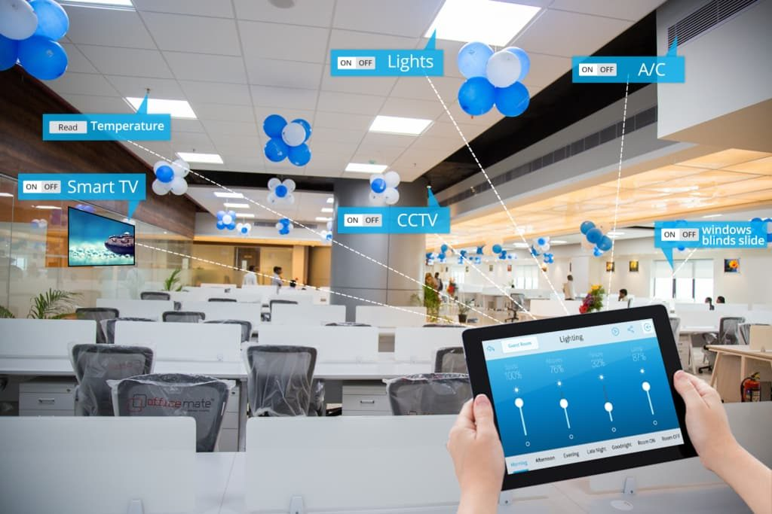

Figure. 2 (IOT Integrated Office)

When IOT technology is used in a smart workplace, it implies that numerous gadgets in the office are linked to the internet and can be controlled remotely. These gadgets are self-contained and collect data without the need for human contact. Offices can be more productive than ever before thanks to smart technology, which allows tedious tasks to be automated so that employees may focus on more important initiatives. There are several ways to benefit from smart office technology.

## Sensors

Figure. 3 (Sensors used for detection)

Figure. 4,5 (This is a PIR sensor)

The PIR sensor itself contains two slots, each of which is built of a unique IR-sensitive substance. Because the lens utilized here isn't doing anything, we can see that the two slots can 'see' out past a certain distance (basically the sensitivity of the sensor). When the sensor is turned off, both slots detect the same quantity of IR, which is the ambient amount emitted by the room, walls, or outside. When a warm body, such as a human or animal, passes by, one half of the PIR sensor is intercepted, resulting in a positive differential change between the two halves. When the heated body departs the sensing region, the sensor creates a negative differential change, causing the sensor to generate a negative differential change.



Figure. 6 (Office with Automatic Lights)

One of the biggest and most obvious benefits of automatic lights in office workspaces is the utility saving potential. When lights are automatic, they are set to come on and shut off again at specific times of the day. This means there will never be an issue of lights being left on overnight when the last to leave the building forgetting to switch the fixtures off. This will help save a lot on monthly utility costs while also helping you to streamline the exact times when illumination is really needed for your location.

Table.1 Electrical consumption on both Normal and Automatic Lights

| **No.** | **Year (NL)** | **Year (AL)** | Electricity Consumption (GWh) (NL) | Electricity Consumption (GWh) (AL) | **Efficiency** |
| --- | --- | --- | --- | --- | --- |
| 1. | 2012 | 2012 | 121,229 | 120,112 | NL < AL |
| 2. | 2013 | 2013 | 127,811 | 123,412 | NL < AL |
| 3. | 2014 | 2014 | 133,178 | 130,001 | NL < AL |
| 4. | 2015 | 2015 | 135,449 | 129,879 | NL < AL |
| 5. | 2016 | 2016 | 135,209 | 130,020 | NL < AL |
| 6. | 2017 | 2017 | 149,320 | 110,229 | NL < AL |
| 7. | 2018 | 2018 | 148,700 | 120,035 | NL < AL |
| 8. | 2019 | 2019 | 162,343 | 125,563 | NL < AL |
| 9. | 2020 | 2020 | 176,973 | 137,963 | NL < AL |
|  |  |  |  |  |  |

As you can see that the smart lights saves more energy and being efficient. In the past years lot of them changed and started having smart appliances and smart bulbs as well

# Method Analysis

## Entering and Leaving System

Figure. 7 (Code for Face detection)

Now here I am making a system which detects face and stores data to the database. This is the code for the face detection in real time and stores data in the database and send alert to the IOT (Internet of Things) which send information to the smart light and the light will turn on.

And when the person is leaving the room the face detection starts detecting the face and removes the face from the data. But still the light is still turned on because there might be some people who might still be in the room.

Only when everyone leaves the room and face detection removes face from the data the turns off after 1 minute. Maybe I will go further in my final thesis



Figure. 8 (Reala time face detection code line)

Here we are calculating or reading your face in real time. It detects and face stored in the database.



Figure. 9 (code for red boders around face)

Here we are drawing or giving a square around your face, and I gave some color to the square. So, I gave red Color to the square around the face. You can see in the next page how the real time face detection works and how it draws a square around the face.

## Real time face detection

As you can see in figure 8 real time multi face detection. Image-based approaches, in general, depend on statistical analysis and machine learning techniques to discover the key aspects of face and non-facial pictures. The learnt attributes are represented as distribution models or discriminant functions, which are then utilized to recognize faces. We employ a variety of techniques in this strategy, including neural networks, HMM, SVM, and AdaBoost learning. We'll examine how to recognize faces with MTCNN, or Multi-Task Cascaded Convolutional Neural Network, which is an image-based method to face identification, in the next part.

Figure. 10 (Multi Face detected image)

After Face recognition technology allows for the creation of a one-of-a-kind numerical code known as a faceprint. A face recognition database stores these faceprints. If you upload a photo to the database, it will search for any similar faceprints. Faces in the Wild: Labeled is a library of face photos created to investigate the topic of unconstrained face recognition. More than 13,000 photos of faces were gathered from the internet for the database. The name of the individual pictured has been written on each face.

# Raspberry pi as security cameras

We'll use the OpenCV, face recognition, and imutils packages to train our Raspberry Pi on a series of photographs that we gather and offer as our dataset for facial recognition. We'll use train model.py to evaluate the photos in our dataset and build an encoding. Pickle file with a mapping between names and faces.

We'll run facial req.py to recognize and identify faces when we've finished training our Pi. We've also included some extra code that will send you an email when a face is identified.

Depending on your Raspberry Pi model and internet bandwidth, this facial recognition project will take at least 3 hours to finish. The majority of this training is focused on terminal commands being executed.

Figure. 11 (Raspberry pi for face detection)

1. What You'll Need for Facial Recognition on the Raspberry Pi:
2. Raspberry Pi 3 or Raspberry Pi 4
3. MicroSD card, power supply, keyboard, mouse, monitor, and HDMI cable (for your Raspberry Pi)
4. USB Webcam

## Smart bulbs

Office lighting has a significant impact on an organization's overall efficiency. The way you light your workplace will have an impact on how effectively your organization performs, from mood to productivity. As lighting technology advances, having the finest smart light bulbs for your business will become more important.

Smart light bulbs provide your company more control over how your area is lit. They are also more energy-efficient and last far longer than standard lights. To keep your business secure, smart light bulbs may also be incorporated as part of your security system. And, while smart light bulbs are more expensive up front, they pay for themselves in the long run.

Figure. 12 (Smart bulbs)

This bulb's built-in motion sensor gives you a lot of possibilities for your workspace. This applies to both indoor and outdoor use. When motion is detected within 30 feet, the sensor on this light bulb will automatically turn on. And once lighted, it remains illuminated for 90 seconds before turning off.

Figure. 13 (Smart bulbs with inbuilt motion sensor)

## Smart bulbs connecting IOT

Wireless switches are used in IoT smart lighting, which eliminates the need to wire light switches directly to fixtures. These bulbs are then connected to a network, enabling for cloud-based monitoring and management. Smart lights may be managed by a mobile app or a home/building automation hub, and individual bulbs can be programmed to alter output in a specific manner, thanks to the integration of Wi-Fi, Bluetooth, or a special connection for home automation systems.

Figure. 14 (IOT Integrated with Smart lights)

Networking is used in most smart lighting systems. Each smart light will connect to the network that is closest to it, which is managed by a hub connected to a network router. Users may control smart lights from their smartphones or tablets using this hub. Not all smart systems, however, need the use of a hub or even an internet connection. Cooper Lighting Solutions' HALO Home Smart Lighting System provides a simple method to manage your lighting through Bluetooth connection from any smart device, without the need for an internet connection or a hub.

# Diagram Description automatically generatedALGORITHM FOR ENTERING AND LEAVING MONITORING

Figure. 15 (Algorithm for Entering)

Figure. 16 (Algorithm for Leaving)

### Algorithm(Flowchart) Explanation

### Algorithm for Entering

In this Algorithm from Figure 15(Algorithm for Entering) we can see how the system works and I will explain how it works. First a person entering the room and the motion detection detects if any one is entering the room or not. If YES, the face picture storing and goes to face extraction it stores data (Face which is detected) and the machine goes to the next process if the face ID valid then it stores data of that person, and the light will be turned on and if no the detection goes back to the motion sensor. And using the IOT the light is turned ON

### Algorithm for Leaving

In this Algorithm from Figure 16 (Algorithm for Leaving). The system starts and reads the data from the data base and if there is anyone in the room if YES it goes back to the reading data part and if NO it turns of the light after 5 minutes and again goes back to the process from start.

# RESULTS & CONCLUSION

## Results

1. Research on Smart lights was done
2. Study about sensors
3. IOT is helpful after connected to the smart lights was shown above
4. Face detection while entering and leaving the room was done
5. Real time Face detection was done
6. Multiple face detection created
7. Efficiency of power using smart lights
8. Raspberry pi as face detecting product
9. Algorithm for the whole System
10. Smart Light research was done
11. Research about IOT

## CONCLUSION

1. In this Term Paper we can se that the smart lights play a major role with Internet things(IOT).
2. And it also saves up lot of energy and helps us to work efficiently. Offices can be more productive than ever before thanks to smart technology, which allows tedious tasks to be automated so that employees may focus on more important initiatives.
3. There are several ways to benefit from smart office technology. here I am making a system which detects face and stores data to the database.
4. This is the code for the face detection in real time and stores data in the database and send alert to the IOT (Internet of Things) which send information to the smart light and the light will turn on.
5. First a person entering the room and the motion detection detects if any one is entering the room or not. If YES, the face picture storing and goes to face extraction it stores data (Face which is detected) and the machine goes to the next process if the face ID valid then it stores data of that person, and the light will be turned on and if no the detection goes back to the motion sensor.
6. And using the IOT the light is turned ON.
7. The system starts and reads the data from the data base and if there is anyone in the room if YES it goes back to the reading data part and if NO it turns of the light after 5 minutes and again goes back to the process from start.